# Title is typed with a Heading 1 style (14 pt), do not capitalize individual words

## F. Author1, S. Author1, T. Author2 (Heading 2 style, 11 pt)

### 1First affiliation, address (Heading 3 style, Times New Roman 10pt, italic),

### 2Second affiliation, address (Heading 3 style)

### Email of communicating author@institution.org (Heading 3 style)

This document explains how to prepare an abstract for the international workshop Frontiers of Racetrack Memory - Status and Prospects. Abstracts should be limited to **ONE PAGE,** following this style including figures, tables and references. Please follow the guidelines given in the following text. You can use this document as a template. The submitted document should be either a Microsoft Office Word file (*.doc, *.docx) or a *.pdf file.

All paragraphs must be typed with the style Paragraph (Times New Roman 11 pt).

Use *italics* to emphasize a word or phrase. Begin a new paragraph on a new line with no indentation. Please format correctly any sub- and superscripts 1 2 and special symbols (greek α Ω, use ° for degrees).

Each **figure** should include a caption placed below it. Number the figures and refer to them as Fig. 1 *etc*. The figure layout ‘*in line with text’* should be used.

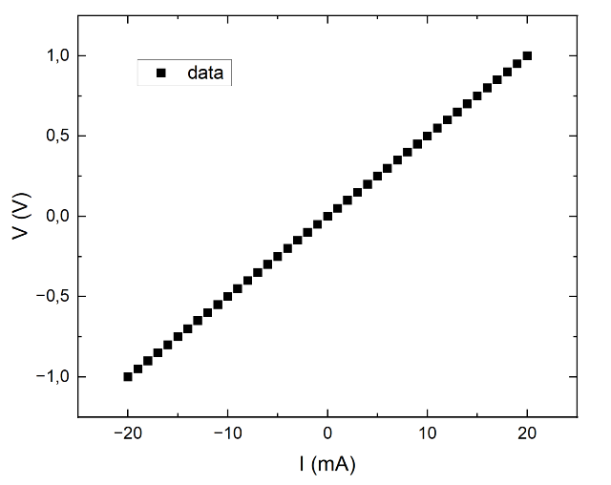

**Figure 1**. This is a figure caption (Caption style, Times New Roman 10 pt).

References should be given in the text by square brackets [1]. Two or more references at a time may be put in one set of brackets [2-4] or [2, 3]. The references are to be numbered in the order in which they are cited in the text.

Use equation editors for any equations present in the abstract. For block equations, use a table environment as shown in the example below, eq. (1):

|  |  |
| --- | --- |
| *a*2 + *b*2 = *c*2 | (1) |

The references should be in Heading 4 style (Times New Roman 11 pt) and listed immediately at the end of the text, without a heading.

#### [1] A. Author, B. Author, and C. Author, *Journal*, **Volume**, Page (Year).

#### [2] A. Author, *Title of Book*, Publisher, City (Year).

#### [3] A. Author and B. Author, *Conference*, Dates, City, Country, Page (Year).

Any acknowledgements authors wish to make should be included at the end of the manuscript with no heading (use Acknowledgement style, Times New Roman 11 pt, italics).